Vishal Maru

Assignment 1

IT 418 – Foundations of Data Science

Dr. Rajeev Bukralia

March 8, 2020

1. Jimmy’s Best Burgers Marketing mix analysis
   1. Important elements for each of the steps
      1. Problem Recognition and Framing – CMO has hired me to fine tune the marketing strategy of the company, so they can change the decrease or increase the resources invested in advertisement accordingly. So, he has assumed already that the problem for company’s declined sales and revenue is that particular department. But I need to make sure that the problem assigned to me is the actual problem that I need to solve for the company. Same as the concept of correlation and causation, advertisement in the marketing department can be correlated to the decline in the company’s declining sales and revenues but might not be the causation of it. Using the RACI framework, the stakeholders will be identified first. Then, realizing the scope of the problem will help in going further with the process. This will then giving us an articulated perspective of what information we need to move to the next stage. For this problem though, it is assumed that the problem with declined sales and revenue lies within the advertisement part of the marketing department.
      2. Review of Previous Findings
         1. Communication to articulate all the information gathered from the CMO will be next step. The process behind how the company reached at their conclusion is crucial to learn. After that is realized, a perspective is to be formed behind the reasoning of the problem. This will help in understanding the process and steps needed to require the problem; even modify the problem as needed. This step of the process is crucial as it helps in giving as more information regarding the understanding of the company and the data gathered by them.
      3. Modeling
         1. For this step, we need clearly defined and articulated constructs, variables, and operational definitions. Once this achieved, we can select these elements depending on what is essential for the Data model to solve our problem.
      4. Data Collection
         1. Collect the Data using the ETL – Extract, Transform, and Load process. Take the data from all the sources and summarize or transform it into an organized and summarized collection that helps in forming a better perspective about the data. This will cover the cleansing part and optimize the data for analysis. Listwise or pairwise deletion and Mean substitution, Regression for missing data.
      5. Data Analysis
         1. CRISP-DM method will start the data analysis which will be a predictive analysis. Scatterplots will be used to find the type of correlations between variables and then depending on that either Spearman or Pearson techniques will be used.
      6. Model validation
         1. This is an added step which ensures that our model and analysis are helping us achieve our goals by performing validation tests on it. Then the model can be modified if needed.
      7. Presentation and Action
         1. Visuals like word clouds, heat maps (maybe), bubble chart, pie chart, line chart to provide a engaging story to the stakeholders so the decision on the marketing department can be taken.
   2. Information to be collected for each of the following steps
      1. Get more details about the advertisement process. What it exactly is? What platforms? Who are they targeted demographic? How are they classified? How are they targeted? How are the changes in price and menu affecting the sales and profits/losses? How is the demographic other than low income perceiving the ads and sales of the company? What changes does change in menu bring in affect? How does this differ between different regions and demographics?
2. Review of the article “How Companies Learn Your Secrets”
   1. Review Lorem Ipsum
3. Tableau Question
   1. Histogram
      1. 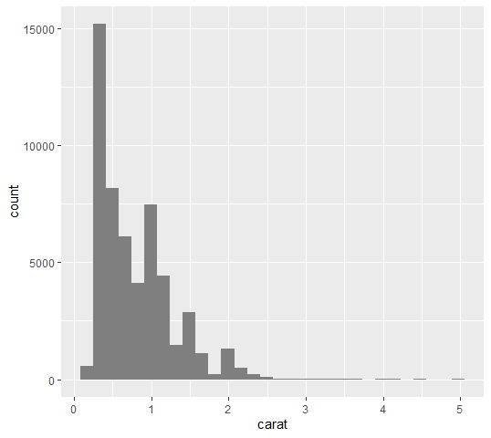
      2. Explaining the Histogram
   2. Scatterplot
      1. 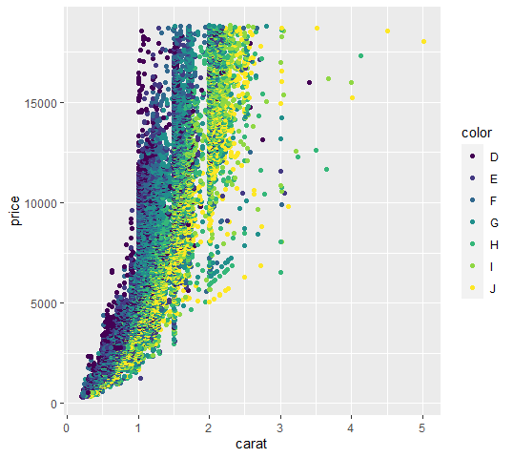
      2. Explain the scatterplot
   3. Boxplot
      1. 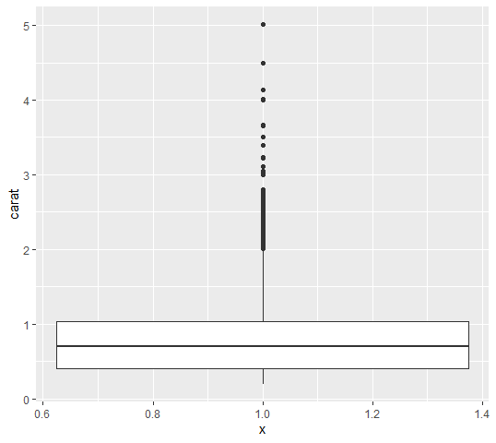
      2. Explain the box plot
   4. Violin Plot
      1. 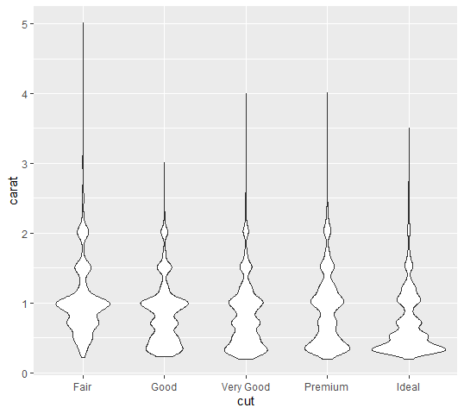
      2. Explain the plot
   5. Overview of the data